California State University Fullerton

CPSC 462



Object Oriented Software Design

Use Case Model

for the



Tuffy Flights

System

|  |  |  |
| --- | --- | --- |
| **Nathan Marcos** | **Jared Castaneda** | **Jawad Swed** |
| Design Modeling, Implementation | Project Management, Implementation | Business Modeling, Design Modeling |
| [nathanmarcos@csu.fullerton.edu](mailto:nathanmarcos@csu.fullerton.edu) | [jaredcast@csu.fullerton.edu](mailto:jaredcast@csu.fullerton.edu) | [jawadswed@csu.fullerton.edu](mailto:jawadswed@csu.fullerton.edu) |

Revision History:

| Version | Date | Summary of Changes | Author |
| --- | --- | --- | --- |
| 1.0 | 9/28/2020 | * Initial Release * Added 3 brief use cases and suggestions * added emails, logos, general formatting * Added use case diagram | Nathan Marcos  Jared Castaneda  Jawad Swed |
| 2.0 | 11/9/2020 | * Adding changes, forgot to edit last iteration * Changed Ticket Scan to Approve Flight Ticket | Jared Castaneda |
| 3.0 | 12/6/2020 | * Renamed use cases to fit a goal * Changed roles | Jared Castaneda |

Table of Contents

1 Use Case Diagram 1

2 Use Case Brief Descriptions 2

2.1 Book Flight 2

2.2 Search Flight 2

2.3 Cancel Flight 2

2.4 View Hotel Advertisement 2

2.5 Accessing Purchased Tickets 2

2.6 Setting a New Account 2

2.7 Approve Flight Ticket 2

2.8 Change Password 3

2.9 Update Flights 3

**Error! Hyperlink reference not valid.Error! Hyperlink reference not valid.Error! Hyperlink reference not valid.Error! Hyperlink reference not valid.Error! Hyperlink reference not valid.Error! Hyperlink reference not valid.Error! Hyperlink reference not valid.Error! Hyperlink reference not valid.Error! Hyperlink reference not valid.Error! Hyperlink reference not valid.Error! Hyperlink reference not valid.Error! Hyperlink reference not valid.Error! Hyperlink reference not valid.Error! Hyperlink reference not valid.**

# Use Case Diagram

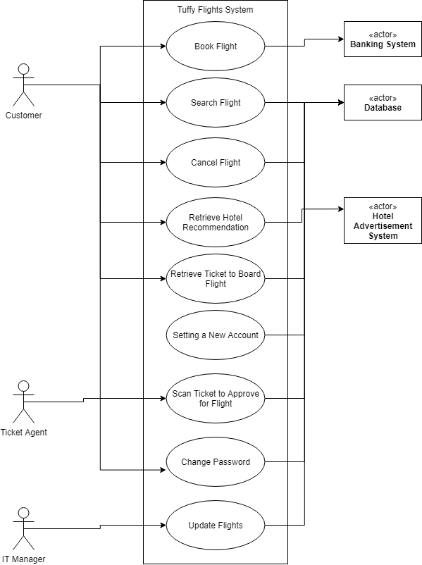

# Use Case Brief Descriptions

## Book Flight

A customer requests to log into the system. The system authenticates and gives flight options. The customer chooses desired flight. The system gives a running total and requests payment information. The customer enters payment information. The system validates and records. The system updates the flight reservation log and sends currency to the banking system. The customer receives a receipt and a digital plane ticket from the system that can be used digitally or printed.

## Search Flight

A customer requests to log into the system. The system authenticates and gives flight options. The customer enters flight airline, date, location, flight number, or flight price. The system responds with a catalog for the customer to view.

## Cancel Flight

A customer with a purchased ticket requests to log into the system. The system authenticates and allows the customer to manage purchased tickets. The customer requests for desired flight reservation to be cancelled. The system validates and records. The system updates the flight reservation log and returns currency from the banking system to the customer. The customer receives a return receipt.

## Retrieve Hotel Recommendation

A customer requests to log into the system. The system authenticates and gives flight options. The customer chooses desired flight. The system gives a running total and requests payment information. The customer enters payment information. The system validates and records. The system updates the flight reservation log and sends currency to the banking system. The customer receives an advertisement for a hotel based on the flight destination. The customer reserves a hotel room and receives a receipt from the 3rd party hotel system. The customer receives a receipt and a digital plane ticket from the system that can be used digitally or printed. The customer

## Retrieve Ticket to Board Flight

Customer logs into the system. Customer asks the system to display their purchased flights. System database populates the customer purchased flights. Customer selects the desired flight for more information. System shows the customer their flight details, receipt, and flight ticket. Customer asks the system to show the flight ticket. System retrieves the flight ticket form the database. System presents the user with their flight ticket. Customer request to log out of the system. System logs customer out.

## Setting a New Account

Customer is using the system for the first time. System ask the customer to set up a new account. Customer input their email and desired password. System sends the customer an email that has a code. System prompt the customer to enter the code. If the customer enters the code correctly then the system creates a new profile and saves the customer login information in the database.

## Scan Ticket to Approve for Flight

The system provides the Customer with their ticket. This is through a printed PDF, a printed email, or on their smartphone. A customer shows their ticket in one of the three ways listed to the ticket agent. The ticket agent requests to scan the ticket provided. The system responds with the new ticket status of “Used,” user verification and confirmation that the scanned ticket belongs to the Customer’s account. The ticket agent allows the customer to board the flight.

## Change Password

User decides they want to change their password. User goes into their account settings. The user provides their own password to verify their account before making any account changes. The system asks for two factor authentication if it is set up. The user decides on a new password that fits the proper criteria and inputs it twice. The system processes the newly selected password and updates the user’s stored security info inside the database.

## Update Flights

IT manager wants to add flights to the System. System asks IT manager for the info regarding the flights, such as origin, departure, number of seats, meals, and more. IT Manager confirms everything with the system. The system updates the flight database to display the new flight under proper search conditions.